Code Smells:

1. In class src/migrations/PreferencesMigrations it was found a "Duplicated Code" code smell. In lines 396, 399 and 425, the String "columnNames" is repeated. If this String needs to be changed, it will be necessary to change the value in all its instances (in other words, the code would need to be changed in 3 separate locations). To solve this problem, all the instances of "columnNames” should be replaced by a constant with the same value.

2. The constructor of the class src/gui/openoffice/OpenOfficeSidePanel receives variables who are stored in the class (taskExecutor, dialogService, stateManager, undoManager, ooPrefs) and always appear together (namely in the method createContentPane()). This is a "Data Clump" code smell. The solution to this code smell would be creating a new class, as long as this is possible without making it a data class.
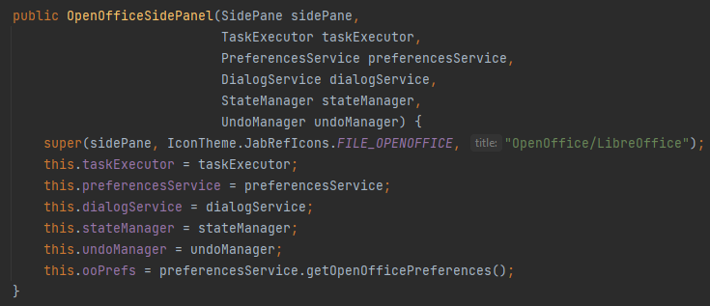

3. Class src/model/database/event/AutosaveEvent is empty. This is a "Speculative Generality" code smell since the existence of this class isn’t necessary at the moment, it may only be needed in future versions of the program. For this reason, unless any function is added to this class, it should be deleted.
